|  |  |
| --- | --- |
| Harrow Council Logo | |
| REPORT FOR: | HEALTH AND WELLBEING BOARD | |
| Date of Meeting: | 2 May 2019 | |
| Subject: | Health and Social Care Focus Group. | |
| Responsible Officer: | Joint report:  Visva Sathasivam, Interim Director  Adult Social Services (DASS)  Javina Sehgal, Managing Director, Harrow Clinical Commissioning Group | |
| Public: | Yes | |
| Wards affected: | All | |
| Enclosures: | None | |

|  |
| --- |
| Section 1 – Summary and Recommendations |
| This report gives an update of the Harrow Learning Disabilities Health and Social Care focus group that was formed on 25th July 2018 as part of the implementation of Harrow’s Adult Social Care vision. |

# Section 2 – Report

**Background:**

2.1 In March 2018, the Director for Adult Social Service (DASS) presented the new Adults Social Care vision to the Health and Wellbeing Board. The vision promoted a model of community resilience; transforming care from a model of need to one of strengths and empowering people to make meaningful community connections, utilising community assets including the voluntary and community sector. It was incredibly encouraging that at that same meeting, a deputation was presented, proposing a new Harrow Learning Disability Health and Social Care focus group to support the vision.

2.2 We are pleased to be able report on the progress that has been made. This has been made possible by the commitment and dedication of the stakeholders, whom have taken forward this exemplary partnership approach. Further helping to ensure that people with learning disabilities, carers and other key stakeholders are fully represented across health and social care services and partners including voluntary and community services with the representation from self-advocates.

2.3 The Learning Disability (LD) Health and Social Care Focus Group met for the first time on 25th July 2018 and has been meeting every quarter thereafter. The meeting is co-chaired between the Local Authority, Harrow CCG and Carer (non -Statutory Representative). The aim of the group is to fulfil the need for a formal pathway for Harrow citizens of all age with a learning disability and their parents/carers to identify health and social care issues, promoting solutions and actions with Harrow Clinical Commissioning Group (Harrow CCG), the Local Authority (LA), Local Health Trust and the Voluntary sector.

2.4 All members of the group agreed that the purpose of the group was:

* For people with a learning disability and their parents/carers to work in partnership with local health and social care representatives to raise and address health and social care concerns/needs
* To assess relevant, current health/social care services for people with a learning disability and their carers in terms of effectiveness and outcomes
* To identify any gaps in health /social care services for people with a learning disability and their carers
* To invite a wider group of participants to engage and make representations
* To formulate proposed action plans which would improve the health and well-being of people with a learning disability and their carers
* To share information about changes/new developments to health and social care services for individuals with learning disabilities and their carers
* To work collaboratively with other groups, agencies; sharing and receiving information to and from key statutory officers and representatives
* To influence the Health and Social Care agenda and priorities
* To make representation to the Health and Wellbeing Board, Harrow CCG, Central and North West London NHS Foundation Trust (CNWL) Board and Harrow Council Cabinet

2.5 The terms of reference was signed off by the group. The group is represented by individuals with a learning disability and their carers, Harrow CCG, the Local Authority, Local Health Trusts, and Voluntary Sector, who are joining together to identify health and social care issues thereby promoting solutions and action plans. It is also an opportunity to share information about any changes or future developments to Health and Social Care Services.

Over the last year the Health and Social Care Focus group have been working on the following areas:

2.6 **Education Programmes:**

Harrow CCG will fully fund the proposal for 2019-2020 for a series of education sessions for young people (18–25yrs) and adults with a learning disability and their carers living in Harrow.

The rationale is to provide additional education and support for young people and adults with a learning disability and their carers living in Harrow. These citizens may be having difficulty in accessing specialist community health therapy services due to staff recruitment issues at the Kingswood Centre. The plan is to provide immediate practical education and advice on a range of health therapy topics which will act as a ‘stop-gap’ whilst awaiting their consultation with a Specialist Health Therapist.

It would be beneficial for young people and adults with a learning disability and their carers to have the opportunity of attending a series of practical education sessions on a range of health therapy topics to provide ‘stop-gap’ advice whilst they are awaiting their consultation with a Specialist Health Therapist. These education sessions would also provide very useful practical advice on health and well-being for young people and adults with a learning disability and their carers.

The programme is expected to run around 21 sessions over the period using trained therapist and workshop facilitators in addition to expert speakers. The programme is due to start in the next few months.

The aim is to provide a community-based education programme, led by Specialist Health Therapy and Community Nursing Professionals, on a range of health therapy and health promotion topics for young people and adults with a learning disability and their carers.

The key benefits are as follows:

* It would provide ‘stop-gap’ advice to carers whilst they are awaiting their consultation with a Specialist Health Therapist
* It would equip carers with additional skills/information to help with the management of the care of their son/daughter at home
* It would reduce the risk of ‘crisis’ situations occurring , so avoiding hospital admission with all the costs that would entail and avoiding extra stress for the carer
* The Specialist Health Therapists and community nurses would be able to identify the most frequent queries/worries that are being raised by the carers, so highlighting ‘high priority’ needs thereby providing a more targeted delivery of service
* Evaluation from attendees would provide valuable data on how these education sessions have benefitted the carer, and the son/daughter they are caring for and their families.
* The concept of these education sessions would fit in with the some of the main principles of the ‘Enhancing the Health and Social Care Vision – Developing Community Resilience in Harrow.

2.7 **Learning Disabilities Adults Health Passports:**

        In December 2018, London North West University Healthcare NHS trust implemented the Adults Learning Disability and Autism Health Passport. The Learning Disability (LD) Nurse works with Harrow citizens, their parent/carers to support them when accessing the hospital, either as outpatients or on the wards.

The purpose of the Health Passport is to share information about the adults needs to ensure reasonable adjustments can be considered when visiting hospitals, doctor surgeries or other environments. Adults with learning disabilities and their carers should complete the passport and share the information with health professionals. The LD nurse has been rolling out the Adult Health Passport with adults with learning disabilities. She has been visiting a number of professionals to share this information and provide support on how to complete the passports. The passport can be downloaded from the London North West University Healthcare NHS trust website. Harrow Mencap are also supporting families to promote the health passports in the community and to support the completion. Harrow Mencap is developing a short video on the purpose of the passport and how to complete it to promote and raise awareness in the community. The LD nurse has trained several champions to support the implementation and to raise awareness of the Health Passport.

Harrow Council held an event for parent/carers/ professionals in December 2018. It was received well and a number of people expressed their interest in becoming a champion to promote the passport in the local community. Further work is required to develop a passport for those transitioning to adulthood and also a children’s passport.

Information event held at Harrow Civic centre on 17th December 2018:

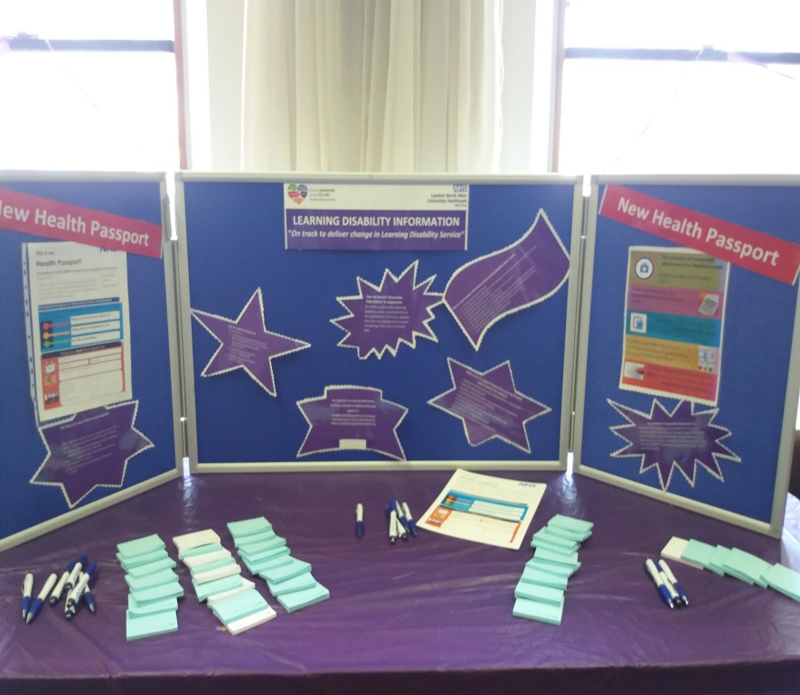

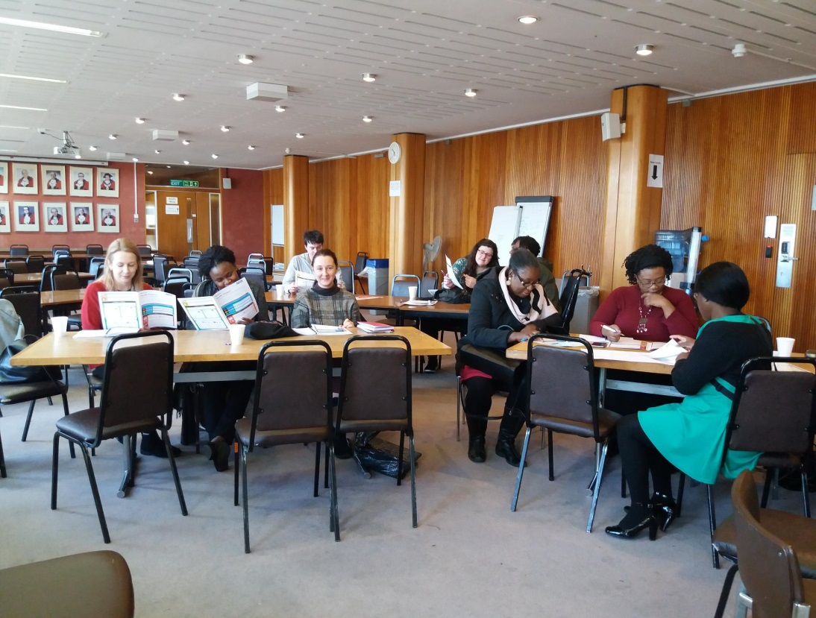

2.7 **Harrow Learning Disability Health and Social Care Focus Group Newsletter**.

The Learning Disability Health and Social Care Focus Group have identified that communication is important and there has been lack of information sharing and therefore have created a Newsletter that will provide information to parent/carers, individual citizens and professionals and will be available in easy read format. It will be distributed amongst Health, Social Care and the Harrow Community.

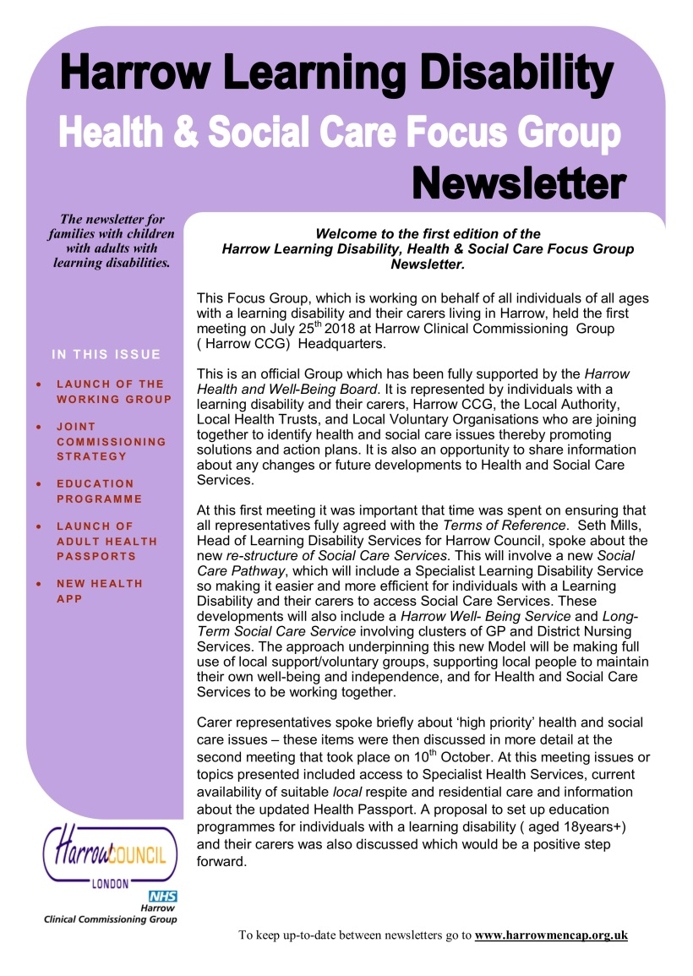

# Section 3 – Further Information

3.1 Adult Social Care and Harrow CCG have also set up an Autism Health and Social Focus Group to fulfil the need for a formal pathway for Harrow citizens of all age with a learning disability and their parents/carers to identify health and social care issues, promoting solutions and actions with Harrow Clinical Commissioning Group (Harrow CCG), the Local Authority (LA), Local Health Trust and the Voluntary sector. This group was formed on 15th February 2019. The Autism focus group will meet quarterly in the same way as the Learning Disability Health and Social Care focus group to address health and social care needs, inequalities and support the autism community.

**Ward Councillors’ comments**

The update report concerns all wards

## Financial Implications/Comments

The implementation of the Learning Disabilities Health and Social Care focus group formed in July 2018 under the Adult Social Care vision have not immediately identified any additional resource requirements.

In light of the financial challenges across both the health and social care economy in Harrow, any future recommended actions will need to be delivered within existing budgetary provision on an ongoing basis. The annual budget process for each organisation will determine the level of available funding in future financial periods.

During 2019-20 Harrow CCG will fund the Education Training Project at a cost of approx. £15k. Any decisions to extend this commitment will need to be considered as part of the annual budget setting process in the context of available resources.

**Legal Implications/Comments**

The purpose of the Health and Wellbeing Board as identified in the Council’s Constitution includes development of a joint health and wellbeing strategy.

## Risk Management Implications

There are no identified risks at this stage. If there are any potential risks that are identified a risk log will in place, risks will be mitigated and signed off by the Corporate Director.

## Equalities implications / Public Sector Equality Duty

Was an Equality Impact Assessment carried out? No

Feedback from a group Service User Representative stated:

* More accessible information about it-more sexual health education people with learning disabilities-more information after education-more help in dealing with relationships
* More support for people when learning disability people visiting hospital
* National health passport
* Give people learning disability people priority for booking double appointments/make it easier for them to do this
* Difference between autism and learning disability-more knowledge of learning disabilities
* NHS/Care staff need more skills with learning disability these include-communication-patience-understanding
* Another learning disability nurse
* We need better doctors and nurses
* People with learning disability concerned about cuts to learning disability nurse support helps a great deal when visiting hospital-help people overcome their minor problems and issues
* Stop people with learning disability dying younger than people without learning disability
* More training for NHS staff around learning disability

## Council Priorities

The Council’s and adult social care vision supports the Councils priorities to support and make a difference for vulnerable citizens, communities and families.

1. **Building a Better Harrow**

* Create a thriving modern, inclusive and vibrant Harrow that people can be proud to call home
* Increase the supply of genuinely affordable and quality housing for Harrow residents
* Ensure every Harrow child has a school place
* Keep Harrow clean
* More people are actively engaged in sporting, artistic and cultural activities in ways that improve physical and mental health and community cohesion

1. **Supporting Those Most in Need**

* Reduce levels of homelessness in the borough
* Empower residents to maintain their well-being and independence
* Children and young people are given the opportunities to have the best start in life and families can thrive
* Reduce the gap in life expectancy in the borough

1. **Protecting Vital Public Services**

* Harrow has a transport infrastructure that supports economic growth, improves accessibility and supports healthy lifestyles
* Healthcare services meet the needs of Harrow residents
* Everyone has access to high quality education
* A strong and resourceful community sector, able to come together to deal with local issues
* Harrow continues to be one of the safest boroughs in London

1. **Delivering a Strong local Economy for All**

* A strong, vibrant local economy where local businesses and thrive and grow
* Reduce levels of in-work poverty and improve people’s job opportunities
* Harrow is a place where people and businesses invest

1. **Modernising Harrow Council**

* Deliver excellent value for money services
* Reduce the borough’s carbon footprint
* Use technology and innovation to modernise how the Council works
* Improving access to digital services

# Section 3 - Statutory Officer Clearance (Council and Joint Reports)

|  |  |  |  |
| --- | --- | --- | --- |
|  |  |  | on behalf of the |
| Name: Donna Edward | x |  | Chief Financial Officer |
| Date: 9 April 2019 |  |  |  |
|  |  |  | on behalf of the |
| Name: Sharon Clarke | x |  | Monitoring Officer |
| Date: 15 April 2019 |  |  |  |

|  |  |  |  |
| --- | --- | --- | --- |
|  |  |  |  |
| Name: Paul Hewitt | x |  | Corporate Director |
| Date: 23 April 2019 |  |  |  |

|  |  |
| --- | --- |
| Ward Councillors notified: | **No**  *.* |

# Section 4 - Contact Details and Background Papers

**Contact:**

Report Author’s name: Mital Vagdia

Job Title: Transformation Project Manager for Learning Disabilities and Autism

Direct telephone number: 020 8736 6418 (x6418) or 07714 182 047

**Background Papers:** None